Lab 8

* 1. 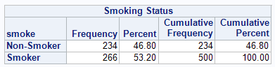
  2. 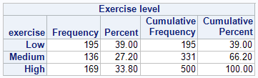
  3. 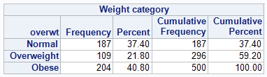
  4. 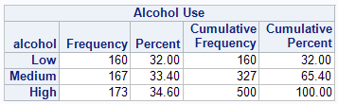
  5. 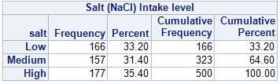
  6. 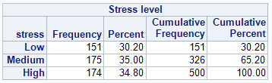
  7. 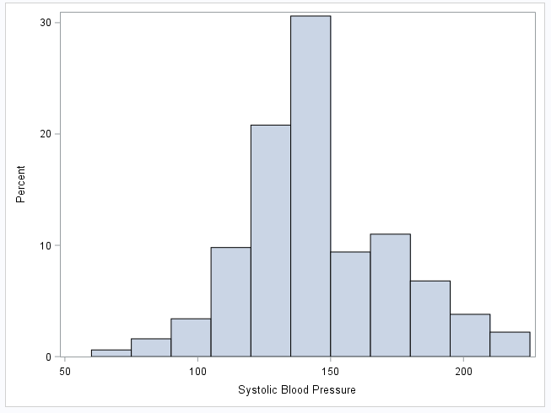
  8. 
  9. 15.4% (77/500)
  10. Error for this Category
  11. 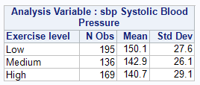
      1. These numbers follow the idea that more exercise leads to lower blood pressure. Those with lower exercise have a higher blood pressure.
  12. 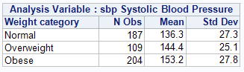
      1. This also follows the idea that someone who is obese will have a higher blood pressure and someone with normal weight will have lower.
  13. 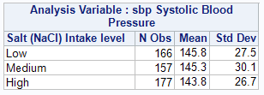
      1. The salt intake does not alter the mean blood pressure in this case.
  14. 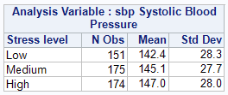
      1. The stress level has a very small effect on the mean blood pressure level.
  15. 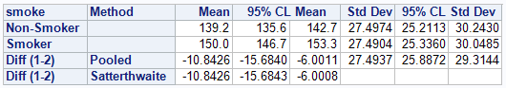
  16. When comparing the Smoker vs. Non-Smoker group, we are 95% confident that the difference between Non-Smoker’s blood pressure and Smoker’s blood pressure is between -15.6843 and -6.0008.
  17. 
  18. Least Squares Mean for Effect Smoke
  19. Ho: all $β_{1}, β_{2}, …, β_{p}=0$ Ha: at least one of $β_{1}, β_{2}, …, β_{p}≠0$ Where $β_{}$ is all of the rows of data in the table.
  20. F-Value = 5.78 and p-value is >0.0033
  21. Reject Ho
  22. At .05 level, there is statistically significant evidence that at exercise has a linear relationship with population blood pressure.
      1. 0.0013
      2. 0.4915
      3. 0.0197
  23. 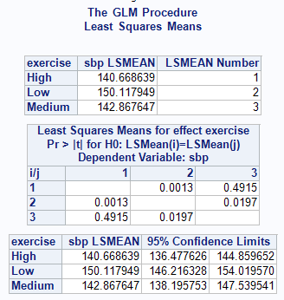
  24. 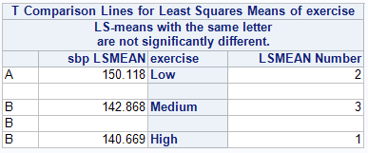
      1. Since the LSMEAN is looking at the LSMEAN number and comparing those two, that is where the values come from in 6a
  25. 95% CI = -15.175, -3.723
  26. We are 95% confident that the difference of blood pressure between someone who exercises a low amount and someone who exercises a medium amount is between -15.175 and -3.723.
  27. 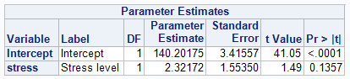
  28. 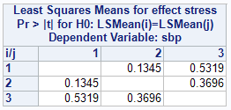
  29. None of them are significantly different for the different levels of stress.